**JULY EXAM PERIOD 2023**

**JULY 11 (Tuesday), 14:00 h (2 pm), Amphitheater SILOS**

* 100 questions (min 51 correct answers to pass exam); duration of exam 120 min
* **Exam results - Thursday, July 13, 14:00 h (2 pm)**
* If you choose wrong answer, you can mark another one but put your signature/initials beside correct answer; **corrected answer without initials will not be accepted!**; you can correct a maximum of 7 questions: 3-bacteriology, 2-parasitology-mycology & 2-virology
* Bringing **indexes** & **fully completed white application form** to the exam is compulsory !
* **Arrive on time on exam** (amphitheater door should be locked 5 min after 9:00)

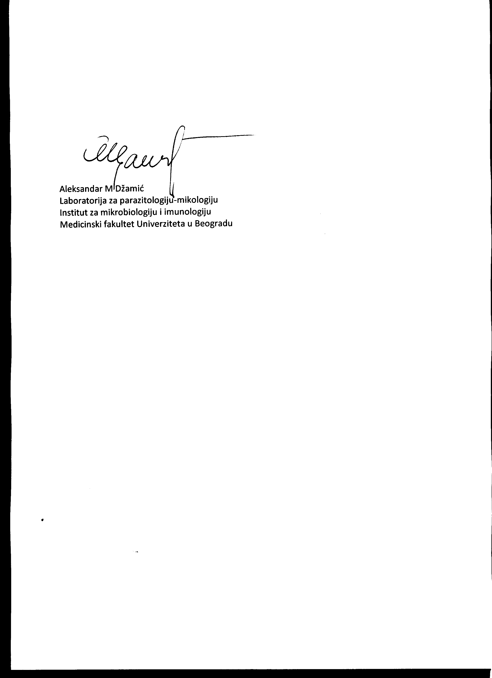

Prof AM Džamić June 22, 2022, Belgrade